****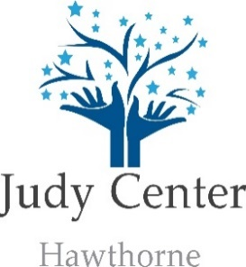**December 2019**

**Contact Information**

410-887-0138

**Facilitator**

Rebecca Lindsey, Ed.D.

**Family Case Manager**

Letethia Nathan

**Upcoming Events**

**A.B.C. Playgroup**

**Currently, full but you may join the waitlist.**

Please contact the Judy Center for more information

**Gingerbread Decorating House Family Night**

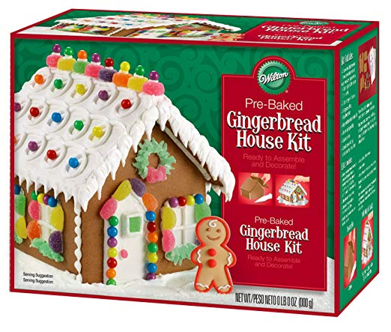

December 17, 2019

Registration required by December 13th

Please contact Ms. Muhammad or the Judy Center

**Winter Break- No School**

**December 23th- January 1st**

**Community Corner**

**Baby Story Time**

Friday, Dec. 6, 13, 20 & 27

10:00- 10:30am

Essex Branch Public Library

**Preschool Story Time**

Friday, Dec. 6, 13, 20 & 27

11:00-11:30am

Essex Branch Public Library

**Story Time with Ms. Pat**

Wednesday, Dec. 18th

10:30am- 11:00am

**Healthy Babies Collaborative:**

**Healthy MOMs**

Tuesdays, Dec. 4, 11, & 18

9:30-11:30am

Stembridge Community Center

**Healthy Babies Collaborative:**

**Essex Breastfeeding**

**Luncheon**

Every Wednesday

11:00-1:00pm

Essex Library

Call: 410-828-7700 ext. 1265

**Fun Things to Do in December with Your Family**

**1. Bake with Your Kids- helps promote literacy and math skills**

**2. Donate Time and Goods to others in need.**

**3. Get to know your neighbors.**

**4. Read a new book as a family (Check out your child’s Winter Break Activity)**



Join us for a free 3 week parent/ infant massage course where you will learn how to:

* use nurturing touch to bond with your baby
* reduce stress levels
* help you and your baby relax

Come discover the many benefits of infant massage, meet other parents and gain confidence in responding to your baby’s cues

Call the Hawthorne Judy Center at 410-887-0138 to enroll.

**\*\*Free Weekly Giveaways\*\***



Join the Judy Center on a Shopping Tour to Lakeshore Learning Store in Towson.

20 parents will have a chance to tour Lakeshore and will be given $50 to purchase learning supplies for their household. If interested, please contact the Judy Center at 410-887-0138

*Transportation to Lakeshore is included, as well as a light snack.